New break through Designer Babies…… what???

Designer Babies
Developments in genetic research and in vitro techniques for reproduction have led some to theorize that, in the near future, wanna-be parents will be able to create designer babies with the specific traits they desire
While the technology isn't yet available, the fact that people are talking about it means there are laboratories willing to make the effort to make it possible, no matter what the ethical costs. At this point in time, we only just beginning to understand how sex is determine in an embryo, or the epigenetic controls that cause one gene to be preferentially expressed over another during blastocyst development. This kind of knowledge could then conceivably be applied to test tube babies, but we are a long way off from that yet.
As we learn more about stem cells and differentiation of pluripotent cells and epigenetic, the concept of controlling cell differentiation becomes more real. If we can control tissue formation and the size and shape of organs and expression of genes controlling human traits, we can make designer babies. The conclusion of the human genome project has also contributed to this fantasy of GM children, since scientists have now sequenced each and every gene in the human cell and we are also well on our way to determining the function of each.

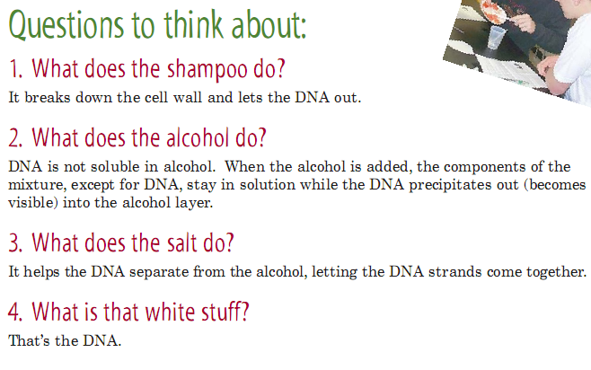
Editorial committee
Anusha, sneha, mahantesh, ishaan, namrata

We are happy to share recent advances in

Biotechnology, DA PHAGE is one of the way to share our ideas

, if you have any new ideas, suggestions, queries or articles

Please feel free to share with us…

Support4bt@gmail.com
Food gradually tastes more bland as the number of taste buds on the tongue is reduced about 2/3rd by age 70

